**Document Based Investigation — Theodore Roosevelt’s Big Stick Diplomacy**

*Teacher Directions/Lesson Plan*

|  |
| --- |
| **Content Outcome**: 5.2.2 (C) Describe the impact of US policy in Latin America, such as the events leading to the construction of the Panama Canal, the Roosevelt Corollary, Dollar Diplomacy, and Moral Diplomacy. |
| **Common Core Literacy Standard**: RH.9-10.6 Compare the point of view of two or more authors for how they treat the same or similar topics, including which details they include and emphasize in their respective accounts.  **Central Historical Question:** To what extent was President Theodore Roosevelt justified in the use of his “Big Stick Diplomacy?” |

**Resources Needed**:

1. Copies of History Lab for students
2. Copy of the PowerPoint –

**Suggested Lesson Sequence**

|  |  |
| --- | --- |
| ***Motivation/Warm Up*** | http://www.awesomestories.com/images/user/c10f49df55.jpg  Students will view the above cartoon. Ask students to write down 3-4 sentences concerning what they in the image. |
| ***History Lab Investigation*** | Review discussion norms with students.  Review expectations for debriefing the activity.  Pass out *Document Based Investigation* to students and have them work in groups to prepare for the debriefing activity. |
| ***Debriefing Activity*** | Have students debrief in a fishbowl activity. Make sure that they use evidence from the documents to support their arguments. |
| ***Closure*** | Students will discuss the United States foreign policy and referencing Theodore Roosevelt’s “Big Stick Diplomacy”. |
| ***Extension (Activity C)*** | Students will analyze a current political cartoon about US foreign policy and answer a question. |

**Document Based Investigation — Theodore Roosevelt’s Big Stick Diplomacy**

|  |
| --- |
| **Central Historical Question**  To what extent was President Theodore Roosevelt justified in the use of his “Big Stick Diplomacy?” |

**Part A Directions:** In order to answer the central historical question, you must first consider the source, purpose, and content of each historical document.  You must also consider how the content of each document corroborates (strengthens) or contradicts evidence found in other documents.  In your group, examine all the documents and then answer the questions that follow.

|  |
| --- |
| **Historical Context**  *Speak softly and carry a big stick, and you will go far*  -African Proverb  Big Stick Diplomacy refers to the foreign policy of President Theodore Roosevelt. One of the major components of Big Stick Diplomacy was the Roosevelt Corollary. The corollary, which President Roosevelt announced in a speech in front of Congress, argued that the United States had the right to enforce an “international police power” over the Western Hemisphere. It affirmed that other countries did not have the authority to cause unrest in the Western Hemisphere, most specifically in reference to conflicts between Europe and Latin America in the early 1900’s. Eventually, the phrase “Big Stick” was used in reference to any foreign policy that made negotiations with diplomatic grace, backed by the possible threat of military force. |

**Document 1:**

This cartoon is titled, *Roosevelt’s Corollary* and it was published in a national publication in 1906.

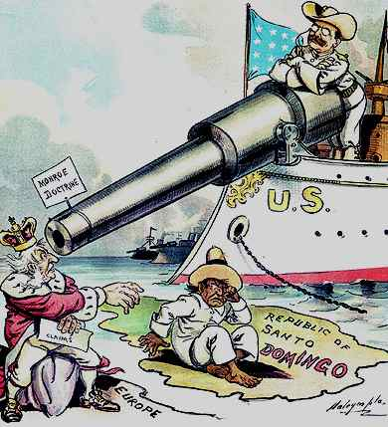

1. Identify the source and type of document.
2. What is the overall idea or message of the document? What can you conclude from the document? How do you think the public reacted to this image? How do you think those the Caribbean and the Philippines reacted? Why?
3. How might this document help you answer the central historical question?
4. How might contemporary events have affected how the author created this source?

**Document 2:**

*In asserting the Monroe Doctrine, in taking such steps as we have taken in regard to Cuba, Venezuela, and Panama, and in endeavoring to circumscribe the theater of war in the Far East, and to secure the open door in China, we have acted in our own interest as well as in the interest of humanity at large. There are, however, cases in which, while our own interests are not greatly involved, strong appeal is made to our sympathies. Ordinarily it is very much wiser and more useful for us to concern ourselves with striving for our own moral and material betterment here at home than to concern ourselves with trying to better the condition of things in other nations.. But in extreme cases action may be justifiable and proper. What form the action shall take must depend upon the circumstances of the case; that is, upon the degree of the atrocity and upon our power to remedy it. The cases in which we could interfere by force of arms as we interfered to put a stop to intolerable conditions in Cuba are necessarily very few.*

Source: Theodore Roosevelt: Monroe Doctrine Corollary speech (1904)." *American History*. ABC-CLIO, 2012. Web. 11 July 2012.

1. Identify the source and type of document. When and why was this speech given? Is it reliable, why or why not?

|  |
| --- |
|  |

1. What is the overall idea or message of the document? Who would agree with/disagree with and/or support this document?

|  |
| --- |
|  |

1. How might this document help you answer the central historical question?

|  |
| --- |
|  |

1. How might contemporary events have affected how the author created this source?

**Document 3:**

After 10 years of construction, the Panama Canal opened on August 15, 1914. The 40-mile canal created a shortcut that lessened the voyage between the east and west coasts of North America by 7,000 miles. The map below shows the sea route before and after the Panama Canal opened.

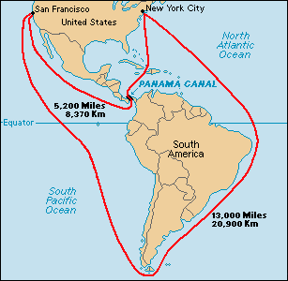

1. Identify the source and type of document. When and why was this written? Is it reliable, why or why not? Is there any bias in the author’s opinion?
2. What is the overall idea or message of the document?
3. How might this document help you answer the central historical question?

**Document 4: Newspaper Article of Panama Canal**

The article below was printed in the Baltimore Sun newspaper on October 5, 1904.

1. ****Identify the source and type of document. When and why was this written? Is it reliable, why or why not?
2. What is the overall idea or message of the document?
3. How might this document help you answer the central historical question?
4. How might contemporary events have affected how the author wrote this source?

**Part B Directions:** As you prepare to debrief this activity, you first need decide how the evidence from the documents helps you understand whether or not you believe that President Theodore Roosevelt was justified in the use of his “Big Stick Diplomacy”?

|  |  |
| --- | --- |
| **President Roosevelt WAS justified in implementing his program of “Big Stick” diplomacy.** | **President Roosevelt WAS NOT justified in implementing his program of “Big Stick” diplomacy.** |
| *Identify three (3) pieces of evidence from the documents that supports this view* | *Identify three (3) pieces of evidence from the documents that does not supports this view* |
| **What other types of evidence/documents do you think you need to help you decide? Why would this evidence/document help you answer the question?** | |

**Part C Directions:** Analyze the cartoon below and then respond to the prompt.

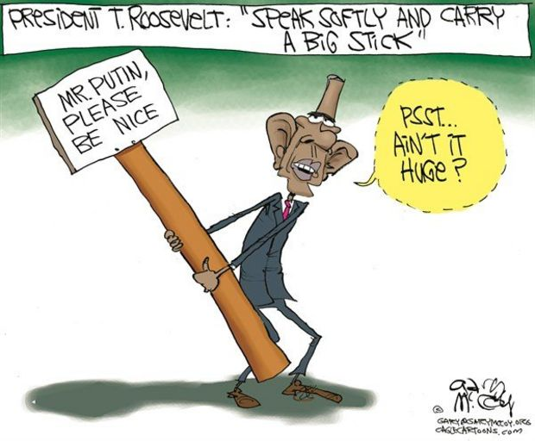

* Do you agree with the cartoonist’s point of view? What message does this cartoon portray? Does the US carry a “Big Stick” today? Use details and examples to support your response.