** MEET THE TEACHER**

**About Me**

Hello my name is Ms. Garcia and this will be my 14th year teaching students in Special Education. I have a special place in my heart for students with a variety of needs and all the exploring, learning and fun we get to have which is why I also tutor students in Reading, Writing and Math outside of the school day.

I have a bachelor’s degree in Special Education K-21. I will be returning to school in the Spring of 2021 to pursue my master’s degree in Psychology to enhance my skill set in working in various areas for student needs.

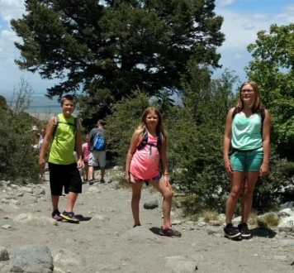I grew up in Chicago, Illinois and moved here to Colorado in the late Spring of 2013. I am an only child and spent most of my years growing up with my grandmother. I am a single mother to Kaitlin, my young actress and singer of 15 years old, Noah, my athlete of 13 years old and child with social emotional challenges and finally Haley, my artist of 12 years old. My son has challenges of his own and is currently on a 504 for supports so meeting the needs of your child is a top priority for me as a parent of a child with special needs. They attend school in Peyton, CO.

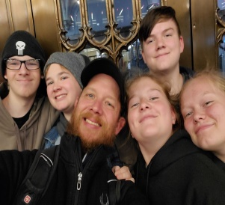

I spend a lot of my free time tutoring, spending time with my children and enhancing my American Sign Language skills to communicate better with my fiancée and his two children. We are a busy family and are always on the move.

I am excited to start this school year 2020/2021 at Elizabeth Middle School as the SSN and 6th grade Mild/Moderate Special Education teacher and am particularly thrilled to spend the next year learning and growing with you!

**My Favorites**

Food: Fruit Smoothies Sports: Chicago Black Hawks Hockey

Movie: While You Were Sleeping Fast Food: Portillos

Color: Blue Animal: Dolphin

Drink: Peace Peach Tea Hobbies: Anything outdoors

Season: Fall Book: Wonder